

Computer Networks

Lab Report

Name ：梁卓文
Student ID ：202130320915
Class ：计算机全英联合班
Collaborator(s) :杨竣尧、谭演锋、郭荣锦

Task 4 Socket Programming
- Experimental Purposes
Objective：
- Master the basic principles and methods of Socket network programming
- Understand the underlying principle of operation of Socket deeply

- Requirement：
- Basic: Implement a client and a server similar with ftp protocol; complete the basic function of file transfer.
List the files/directories
Change working-directory
Download file/s
Upload files/s
Create/remove files/directories
Etc…
- Submit content: document report （include design document, using explanation）, source code，the content above store in 2 folder apart（Doc、Src）
Explain the design of your file transfer program(FTP).
High-layer encapsulation Socket can not be used (like java class library, MFC and so on)

- Explain the usage of socket.h or winsock.h

3. Experimental Environment
Platform: Windows
Developing Language: C
Developing Environment: Visual C++
Group: 4 members/group

- Design Document
- The structure of FTP(Part of)
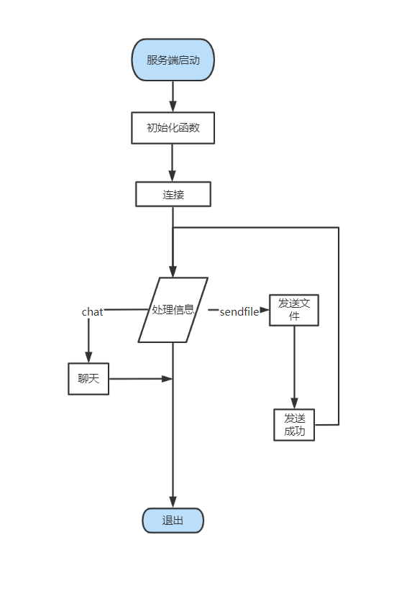
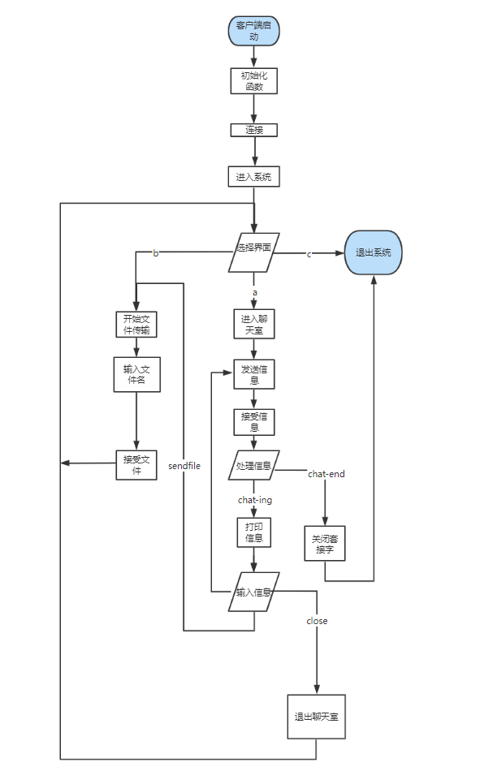
Figure. Server and Client
- Overview of implementation
Processing information is the difficulty and breakthrough point in this development process. In order to combine chat and send files into one program, flag bits are specially set to mark the attributes of sent information. The sent information is encapsulated in a structure, and the two parties process it according to the header information of the sent information when communicating. The server only needs to call a processing information function to run, and the client independently designs the processing function of sending files and the processing function of chatting according to the needs selected by the user. The advantage of this is that the implementation of the program is more organized, the development is more simple and specific, and the later is easy to maintain, optimize and improve.
- Implementation of system processing information
Due to the limitation of the size and capacity of the send cache, it is difficult to transfer large files, but in the actual application environment, simple file transfer can not meet the needs of its users, if the transfer of files is one-time, the system often causes file transfer failure or information loss due to insufficient allocation of memory. In order to solve this problem, the design of this course takes the idea of: the server splits the file to be sent, transmits the data a few times, the client splices the fragments of the data, writes a few times until the information is received.
Here is the general idea behind how the system processes information:
Process of sending file information:
- The client input the file name and send it to the client, marking position 1;
- The server receives the file name, finds whether there is a file, sends the file size to the client, marks the location 2, and opens up the memory space of the send cache; If not, a message without file is sent, marking position 6;
- The client receives the file size according to the file size to open up memory space and send a request to accept, marking position 3; Receive no file message continue to enter the file name and send, marking position 1;
- The server begins to send the file after receiving the request, marking the position 4; After the transmission is completed, send the successful transmission signal, marking the position 5; Close the connection.

- The implementation of unpacket transmission of files
Sending large files adopts the idea of unpacking and processing the sent information with flag bits. The two parties determine what to do next based on the packet header information.
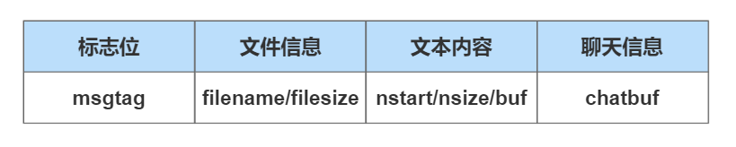
图2.2.2 设计的协议格式
In order to more convenient understanding of its implementation principle, the code is attached to supplement the explanation

enum MSGTAG
{
MSG_FILENAME = 1,//file name
MSG_FILESIZE = 2,//file size
MSG_READY_READ = 3,//tell client be ready to read
MSG_SENDFILE = 4,//sending file
MSG_SUCCESSED = 5,//succeed in sending file
MSG_OPENFILE_FAILD = 6,//failure in opening file
ENDSEND=7,//stop sending file
CHAT_END = 10，//end of program
CHAT_ING=11//start chatting
MSG_DIRECTORY = 12,//make a directory
MSG_DELETEFILE = 15,//delete file
MSG_UPLOAD = 16,//upload file
MSG_PATHNAME = 17, //change path
MSG_UPFILENAME = 18, //upload-first step
MSG_UPFILE = 19, //upload-second step
MSG_UP_READY_READ = 20 //upload-third step
};

#pragma pack(1)
#define PACKET_SIZE (10240 -sizeof(int)*3)//定义包的长度
struct MsgHeader
{
enum MSGTAG msgID;//当前消息标记
union MyUnion
{
struct
{
char fileName[256];
int fileSize;
char filePath[1024];
int pathSize;

}fileInfo;
struct
{
char dirPath[1024];
}dirInfo;

struct
{
int nStart;
int nsize;
char buf[PACKET_SIZE];
}packet;
struct
{
char chatbuf[BUFSIZ];
}CHAT;
};
};
#pragma pack()

In order to facilitate the understanding of the function data structure it constructs, the following describes the details of its server unpacking:
- Packet size (PCKETSIZE) : 10204 bytes, where the flag bit accounts for one byte, the file start position accounts for one byte, the packet data size accounts for one byte, so the sent file information accounts for (10240-sizeof(int)) bytes; In particular, when sending the file content (flag bit is 4), it is not necessary to send the file name and file size, so it does not occupy the space of the package.
- Use nstart to record the location of the file information to be sent, that is, the starting location of the file information when the next packet is sent.
- Record the packet data size with nsize.
- If nstart+nsize+1>f-size, it means that this packet is the last packet, and the sender judges the completion of sending according to this condition.

- Using Explanation
  - Introduction
The project uses the existing computer resources to develop a software that can effectively carry out online chat, file transmission and directory processing, which is divided into client and server. The main work is as follows:
- The server is turned on to listen to the client, receive the connection request and establish a connection.
- When the client is opened, it will automatically connect to the preset server. When both sides are opened, the two can start communication.
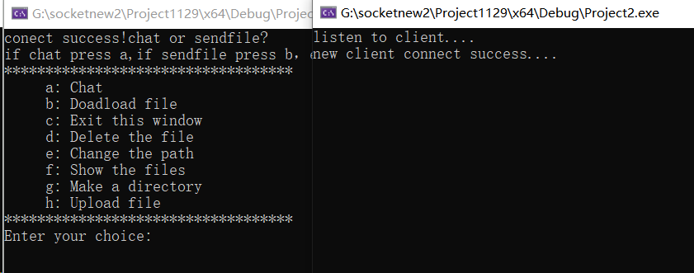
- Print function option on the client interface. The client can select the function to be performed through commands, such as "b" to download the files and "h" to upload files.
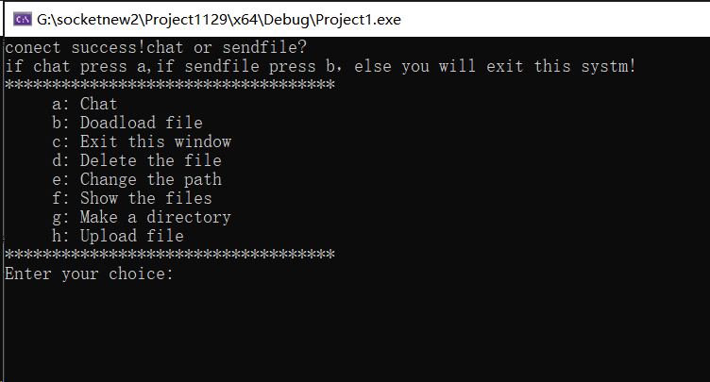
- The server determines which function to perform based on the information sent by the client.
- Chatting
- During the chat, the server can enter the "close" command to actively close the connection to the client.
- During the chat, the client can enter the "close" command to close the connection with the client; Enter the "sendfile" command to terminate the conversation and request to send the file.
- After the server successfully sends the file, the client can choose to continue chatting.
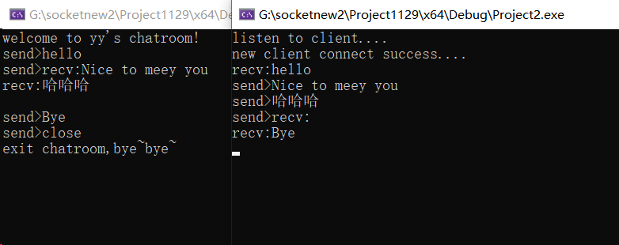
- Download files
Enter the file you want to download. If there is no other path in front of the file, the file path defaults to the root directory of the server.
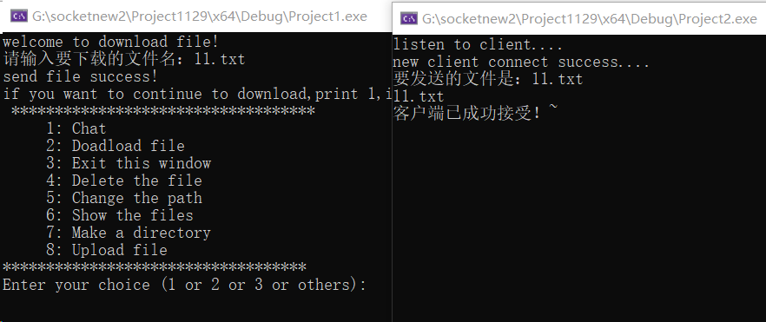
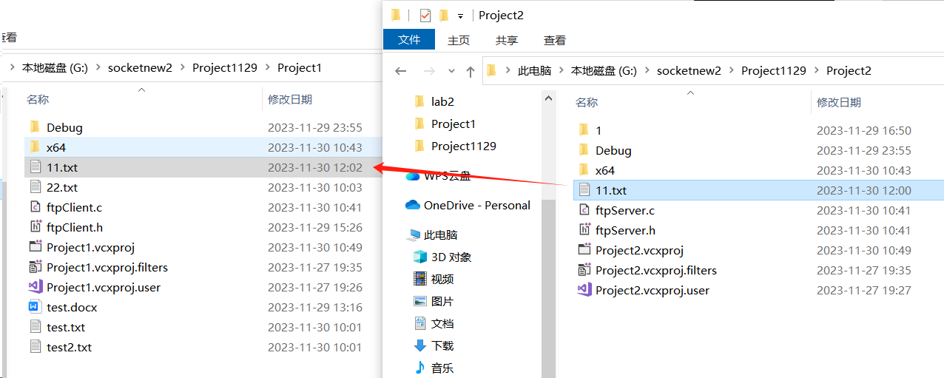
You can see that the server responds to the received request successfully, and the client downloads the file in its path.

- Delete files
Enter the name of the file to be deleted. If there is no path before the file, the file is in the root directory of the server by default.
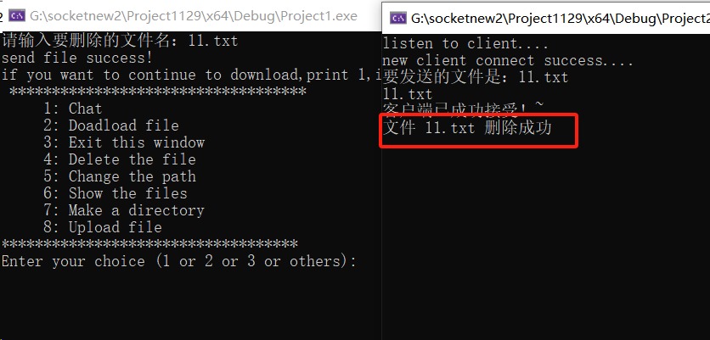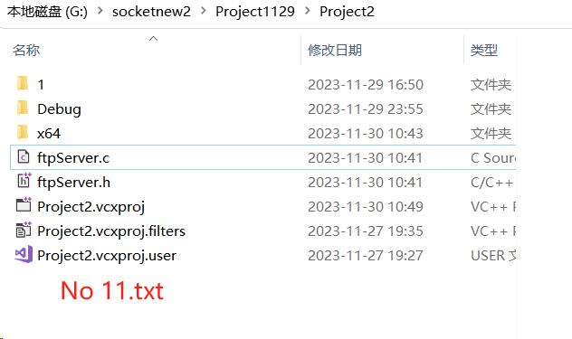
The server replies that the file is deleted successfully. The 11.txt file in the root directory is deleted.
- Change the path
Enter the path you want to change, and the root of the server will be changed to the path you entered
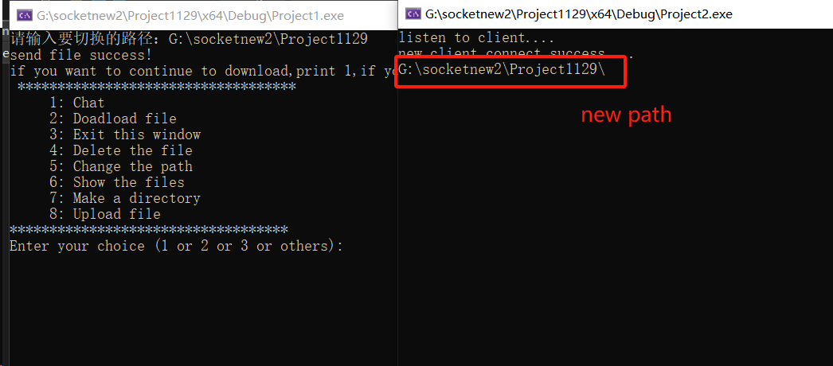
You can see that the server prints the updated path, indicating that the path has been successfully modified.Then use the function of downloading files to test whether the server path has been changed.
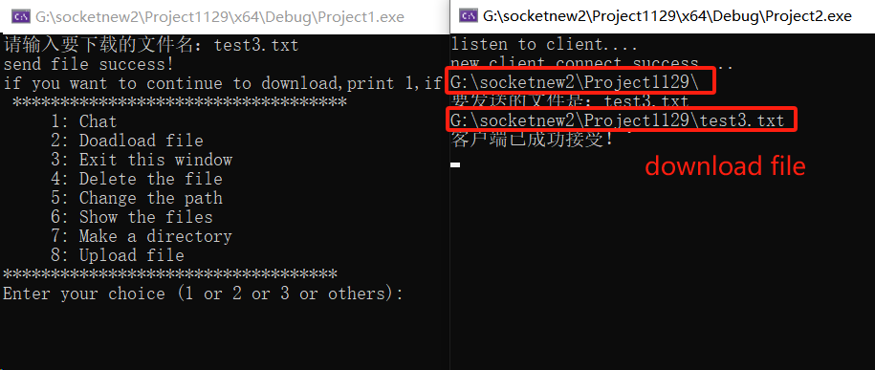
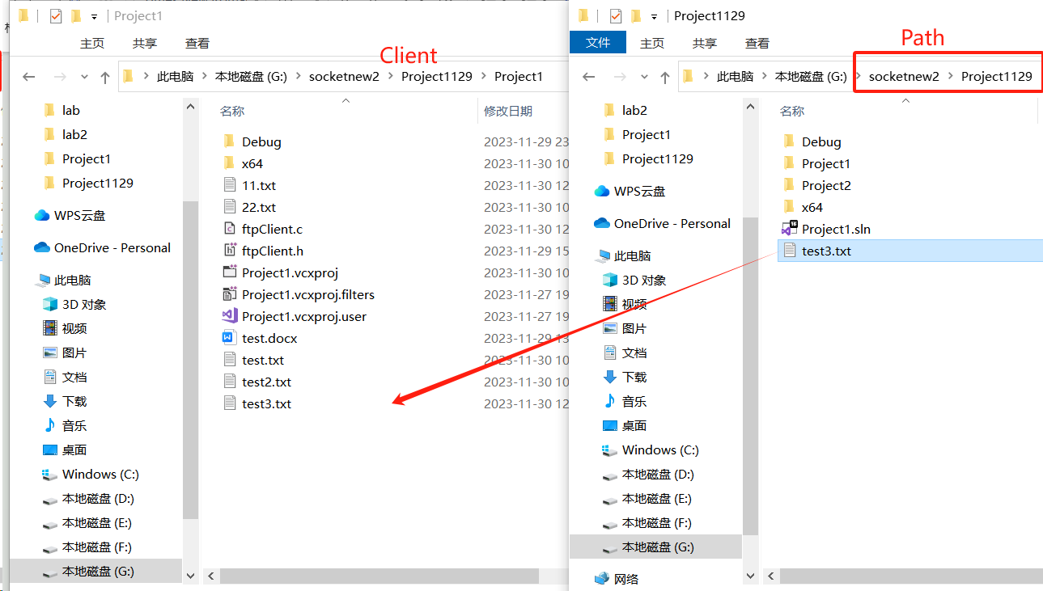
As you can see in the figure above, we changed the path to a directory above the original path of the server, and then entered the file we want to download, test3.txt (without adding an absolute address). Finally, the client successfully downloads the file in its own path, indicating that the path is successfully changed.

- Show the files
Enter the directory or folder path. The client displays all file names or folders in the path.
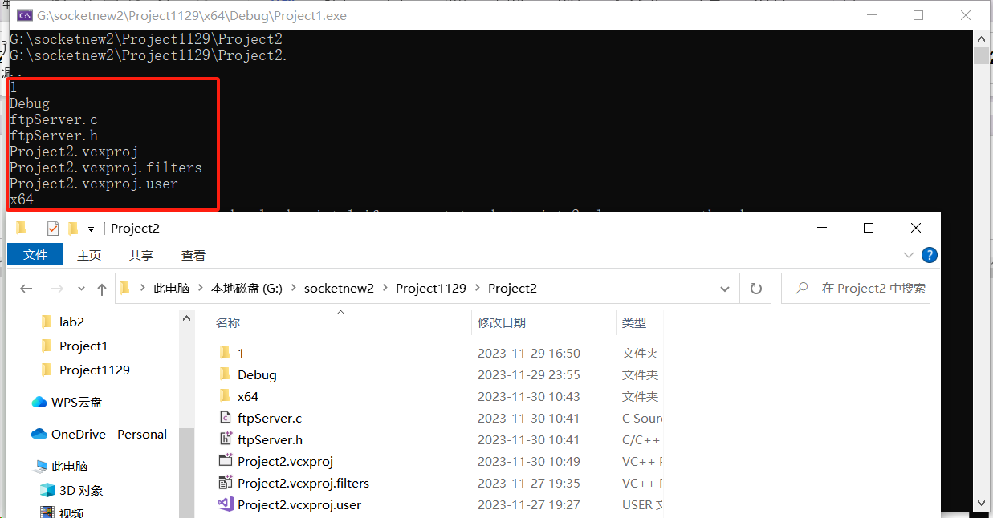

- Make a directory
On the client side, enter the directory you want to create. If no absolute path is specified, the directory is created under the root directory of the server by default. For example, we entered the created folder name 3, it can be seen that a folder named 3 is generated in the server directory.
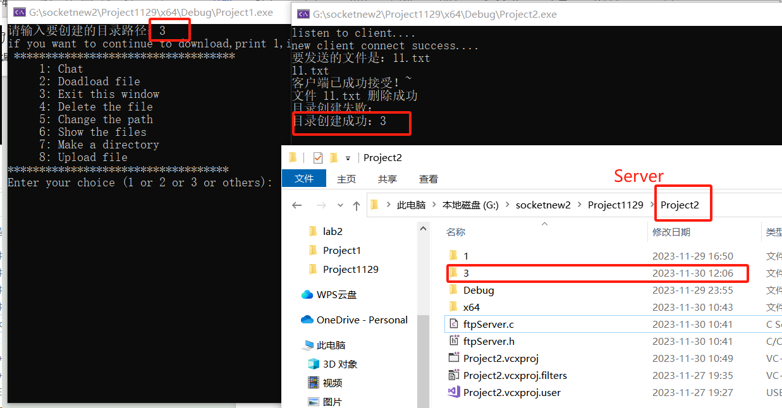
- Upload files
Enter the file to be uploaded. If the address is not absolute, the file in the directory where the client resides will be uploaded by default. The file will be displayed in the server directory.
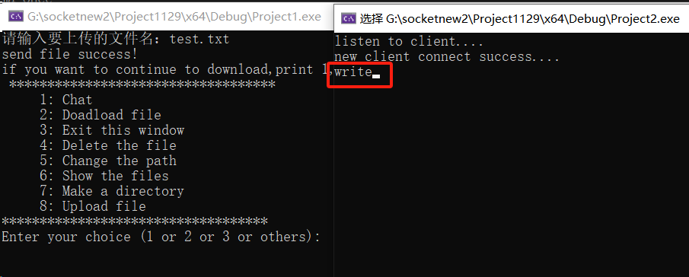
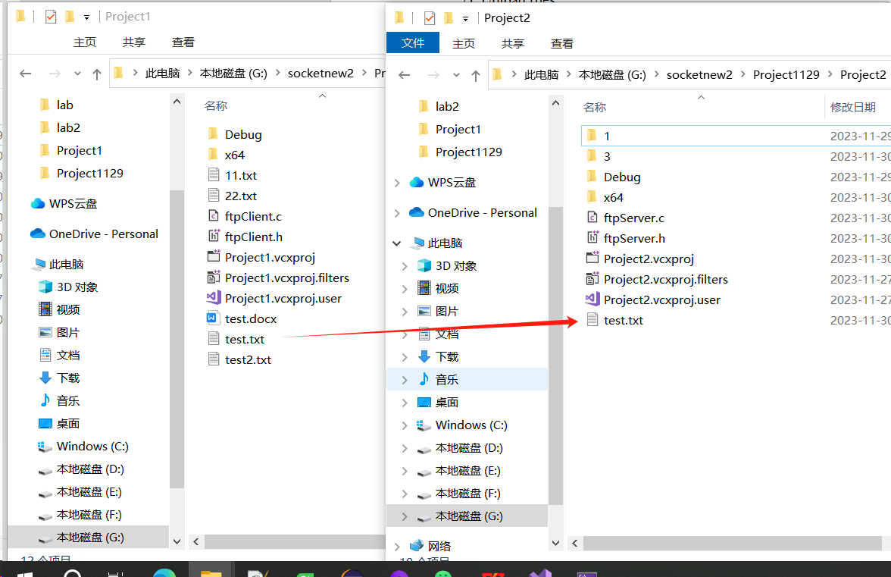
As can be seen from the above figure, the client uploads the file named test.txt, and the server returns "write", which indicates that the file has been written in its own path. You will eventually see the test.txt file in the server path.

- Exit
Enter “c” or “3” to exit the file transfer program(FTP)
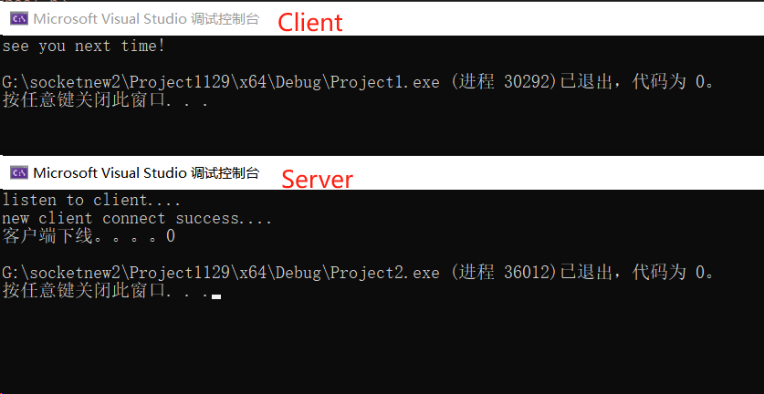

  - Characteristic
- The client can apply to the server for sending large files larger than 100m.
- The communication between the two sides supports the concurrent function, that is, one party can send multiple data or accept multiple data at the same time without blocking.

- Individual report
- My responsible part
I realized the two functions of creating directories and deleting files, and completed the corresponding window instructions. In addition, I also participated in the design of FTP system and MSGTAG, helped the team quickly understand the principle of socket implementation, and set up the code framework of socket.

- Specific operation
- Create a directory
I define MSG_DIRECTORY =12 in client.h and server.h as the message type for creating directories in socket communication, as mentioned in above design document. This message prompts the server to receive a request to create a directory.
According to the using explanation, the client sends a request to create a directory, and the server processes the request and creates a new directory under the root directory.

The client requests to create the directory：
void createDirectory(SOCKET clientSocket) {
char directoryPath[1024];
printf("请输入要创建的目录路径：");
fgets(directoryPath, sizeof(directoryPath), stdin);

// 移除输入字符串中的换行符
size_t len = strlen(directoryPath);
if (len > 0 && directoryPath[len - 1] == '\n') {
directoryPath[len - 1] = '\0';
}

struct MsgHeader directory;
directory.msgID = MSG_DIRECTORY;
strcpy(directory.dirInfo.dirPath, directoryPath);

if (send(clientSocket, (char*)&directory, sizeof(struct MsgHeader), 0) == SOCKET_ERROR) {
perror("send");
return;
}
}
First, I declare an array called directoryPath for the path to the directory that receives user input. Next use the fgets function to read the directory path of user input and store it in directoryPath.
To remove a newline character from a user input string, the function checks if the last character is a newline character and replaces it with the end-of-string character (\0).
An MsgHeader struct object named directory is then created to represent the message to be sent. The MsgHeader structure contains a message identifier msgID and a directory information structure dirInfo.
Assigning MSG_DIRECTORY to the msgID field of directory indicates that this is a message to create a directory. Use the strcpy function to copy the directory path entered by the user into the dirInfo.dirPath field of directory.
Finally, the directory structure is sent to the client's clientSocket through the send function and the return value is SOCKET_ERROR. If an error occurs during the sending process, an error message is printed and returned.

The server processes the request and creates the directory under the root directory：
int createDirectory(SOCKET clifd,const char* directoryPath) {
// use mkdir() to create dist
// The first param is client’s socket，The second param is target path
int result = mkdir(directoryPath, 0777);

if (result == 0) {
printf("目录创建成功：%s\n", directoryPath);
struct MsgHeader msg;
msg.msgID = MSG_SUCCESSED;
send(clifd, (char*)&msg, sizeof(struct MsgHeader), 0);
//return true;
return 1;
}
else {
printf("目录创建失败：%s\n", directoryPath);
return 0;
}
}

Create a directory using the mkdir() function, check the return value of mkdir(). If the value is 0, the directory is successfully created.
If the directory is successfully created, a success message is printed using printf, and an MsgHeader struct object msg is created, and MSG_SUCCESSED is assigned to the msgID field of msg, indicating the successful operation message.
Use the send function to send the msg structure to clientSocket on the client, and use sizeof(struct MsgHeader) to ensure that the correct number of bytes is sent.

- Delete files
I define MSG_DELETEFILE=15 in client.h and server.h as the message type for deleting files in socket communication, as mentioned in above design document. This message prompts the server to receive a request to delete the file.
According to the description using explanation, the client sends a request to delete the file, and the server then processes the request and deletes the file under the root directory.

The client requests to delete a file：
void deleteFileName(SOCKET serfd) {
char fileName[1024];
printf("请输入要删除的文件名：");
gets_s(fileName, 1024);

struct MsgHeader file;
file.msgID = MSG_DELETEFILE;
strcpy(file.fileInfo.fileName, fileName);

if (SOCKET_ERROR == send(serfd, (char*)&file, sizeof(struct MsgHeader), 0)) {
error1("send");
return;
}
}

First, a character array named fileName is declared to receive user input for the filename to be deleted. Use the gets_s function to read the file name entered by the user from standard input and store it in fileName.
Like the createDirectory function in client, I create an MsgHeader struct object named file that represents the message to be sent. The MsgHeader structure contains a message identifier, msgID, and a file information structure, fileInfo. Assign MSG_DELETEFILE to the msgID field of file, indicating that this is a message to delete the file. Use the strcpy function to copy the file name entered by the user into the fileInfo.fileName field of file.
Finally, the file structure is sent to the server's serfd via the send function, the rest is the same as the createDirectory function.

The server processes the request and deletes the file with the same name in the root directory：
void deleteFileOnServer(SOCKET clifd,const char* fileName) {
if (remove(fileName) == 0) {
printf("文件 %s 删除成功\n", fileName);
struct MsgHeader msg;
msg.msgID = MSG_SUCCESSED;
send(clifd, (char*)&msg, sizeof(struct MsgHeader), 0);
return true;
}
else {
perror("删除文件失败");

}

}
The function takes two arguments: clifd represents the clientSocket, and fileName represents the file name to delete.
Delete the specified file using the remove() function, where the argument fileName is the path and name of the file to be deleted. Check the return value of remove(). If it is 0, the file is deleted successfully.
If the file is successfully deleted, a success message is printed, and an MsgHeader struct object msg is created. MSG_SUCCESSED is assigned to the msgID field of msg, indicating the successful operation message.
Use the send function to send the msg structure to clifd on the client, and use sizeof(struct MsgHeader) to ensure that the correct number of bytes is sent.

- The difficulties
- Function pointer conversion: there are many pointer calls in the implementation of the function, type conversion, so in the debugging process reported a lot of mistakes, spent a lot of time to check and adjust. For example, the send function requires passing a pointer to the buffer to send data, and the msg structure may contain different types of data, so it needs to be converted to a char type pointer.
- Path resolution problem: In an FTP client, you may need to specify the path of the target directory to create a directory or delete files. I need to make sure it works in both absolute and relative paths.

- What I have learned
- Deepen understanding of the socket functions MSG_Tag and MSG_Header
It is important to understand the roles of MSG_Tag and MSG_Header in both the client and server. MSG_Tag serves as the message type in socket communication and needs to be assigned as an attribute to the MSG_Header object when implementing functionalities such as creating directories or deleting files. This allows the server to execute the relevant functionalities in response to client requests.
Similarly, it is necessary to understand the fileinfo and dirinfo attributes in MSG_Header. For dirinfo, only the path attribute is needed, while fileinfo requires both the filename and filepath.
- Throughout the process of creating and using sockets for communication, I have become more proficient in utilizing various socket functions such as bind, listen, and send. By implementing the functionalities of an FTP system, I have gained a deeper understanding of the principles and applications of sockets in computer networks.
- When implementing FTP functions, I learned how to handle error messages returned by the server, and how to provide users with useful error prompts and solutions.
4) During this project, I have deeper learning of project management and collaboration.I have learned about task distribution, time management, version control, and communication within your development team.
5) It’s inevitable that there are many problems debugging while testing the program.Throughout the development process, I have learned to adapt to changing requirements, find solutions to technical issues, and overcome obstacles.

Conclusion
In general, through this FTP experiment, I not only practiced the knowledge of network programming and FTP protocol, but also improved my understanding of the concepts of socket, data transfer and error handling. This experiment provided me with a foundation for further study and application of network programming, and provided me with valuable experience in dealing with file transfer and network communication in future projects.

Comments and mark:

